Pathway mapping
Pathways associated with altered CAPN1 expression
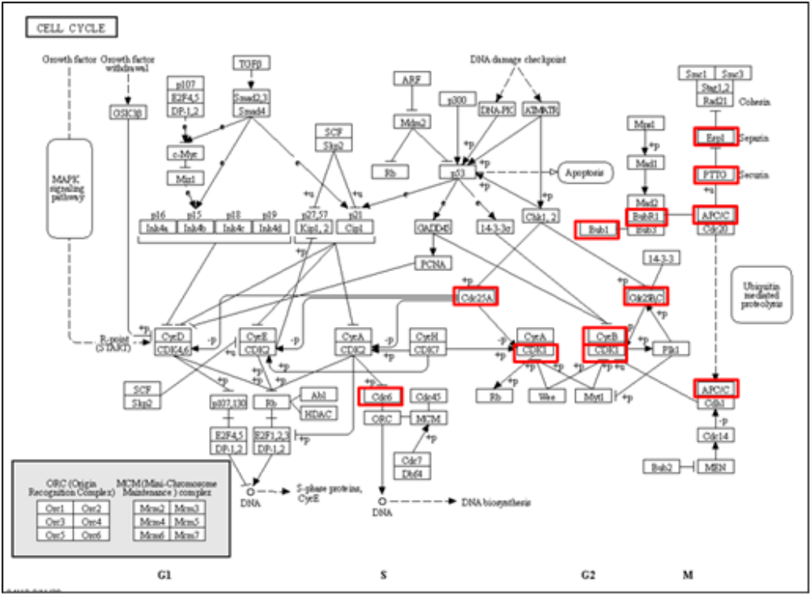
Cell cycle pathway. Cell cycle pathway mapped with significantly altered genes associated with altered expression of CAPN1.
Pathways associated with altered CAPN2 expression
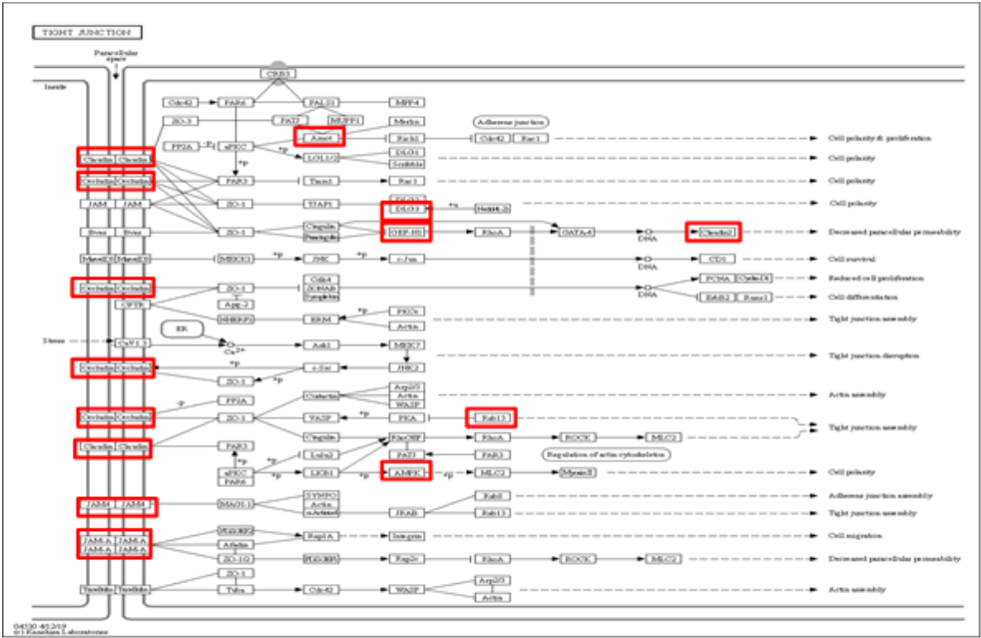
Tight junction pathway. Tight junction pathway mapped with significantly altered genes associated with altered expression of CAPN2

Pathways associated with altered CAPN4 expression
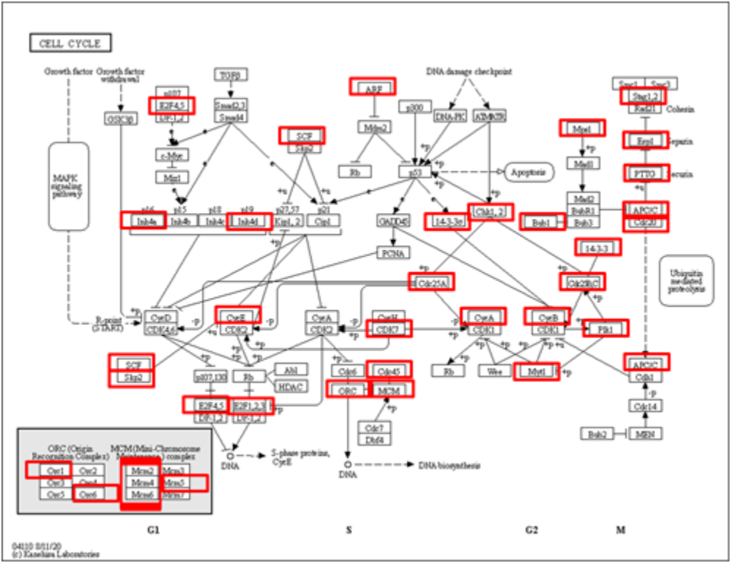
Cell cycle pathway. Cell cycle pathway mapped with significantly altered genes associated with altered expression of CAPN4.
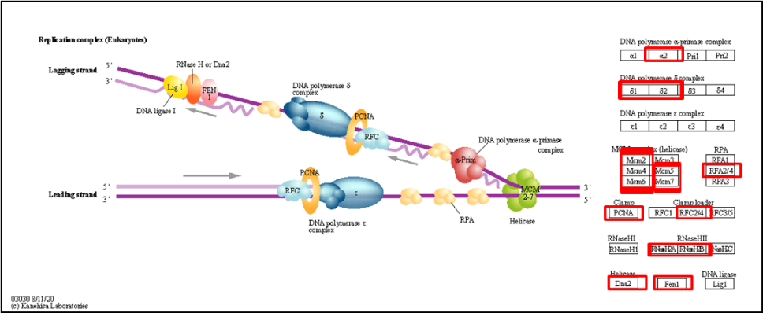
DNA replication pathway. DNA replication pathway mapped with significantly altered genes associated with altered expression of CAPN4.
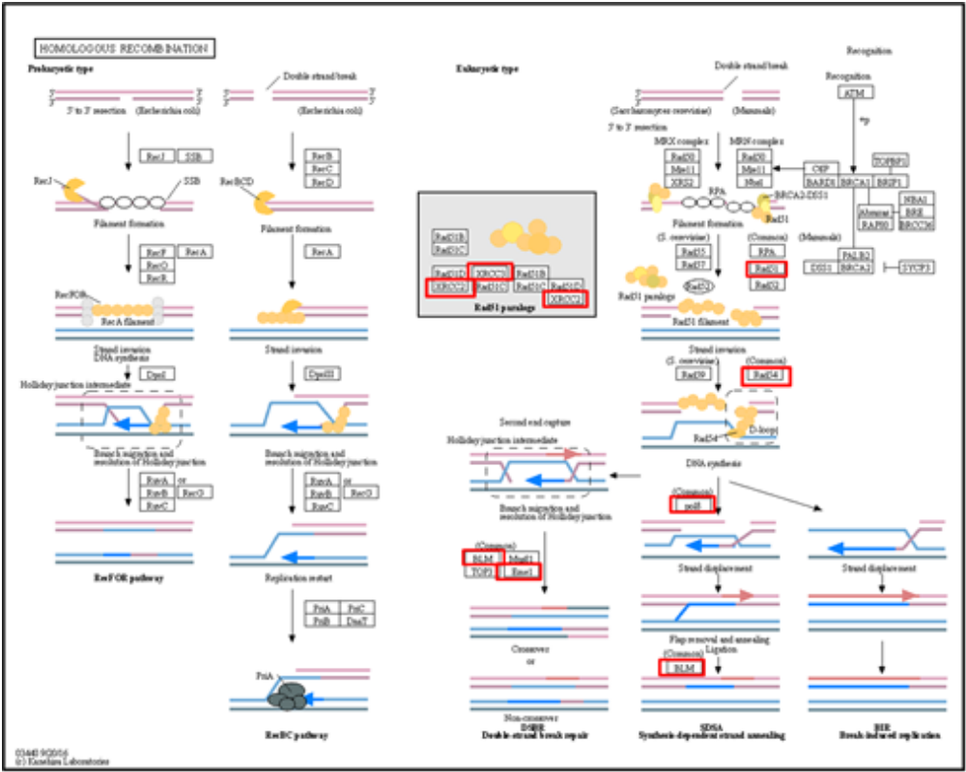
Homologous recombination pathway. Homologous recombination pathway mapped with significantly altered genes associated with altered expression of CAPN4.
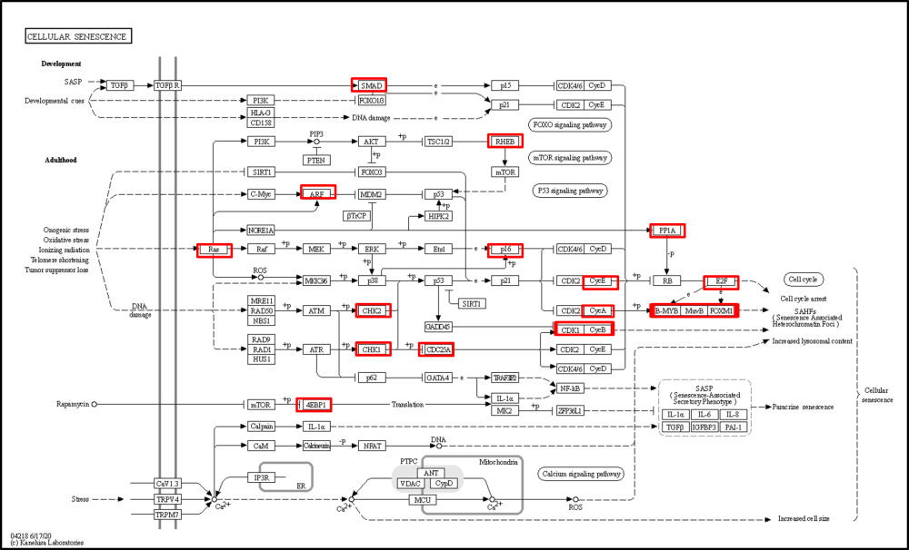
Cellular senescence pathway. Cellular senescence pathway mapped with significantly altered genes associated with altered expression of CAPN4.
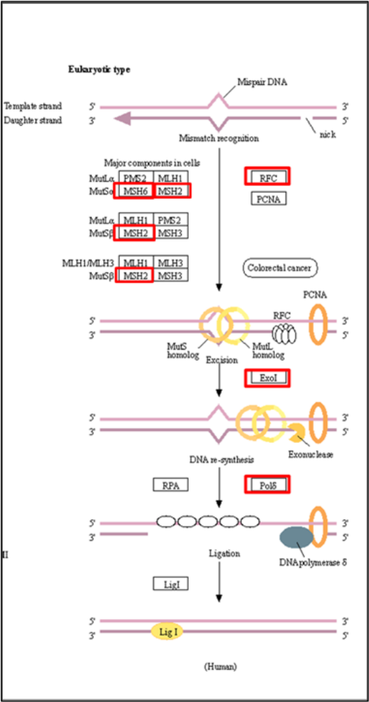
Mismatch repair pathway. Mismatch repair pathway mapped with significantly altered genes associated with altered expression of CAPN4.

Pathways associated with altered CAST expression
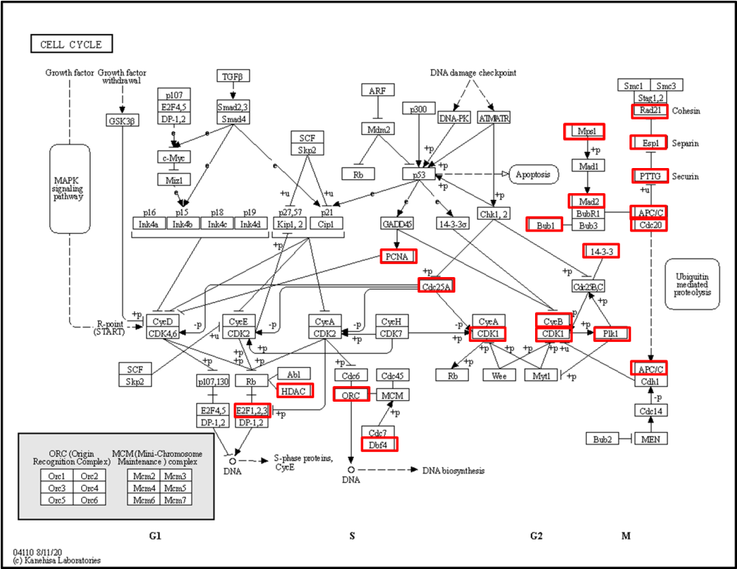
Cell cycle pathway. Cell cycle pathway mapped with significantly altered genes associated with altered expression of CAST.
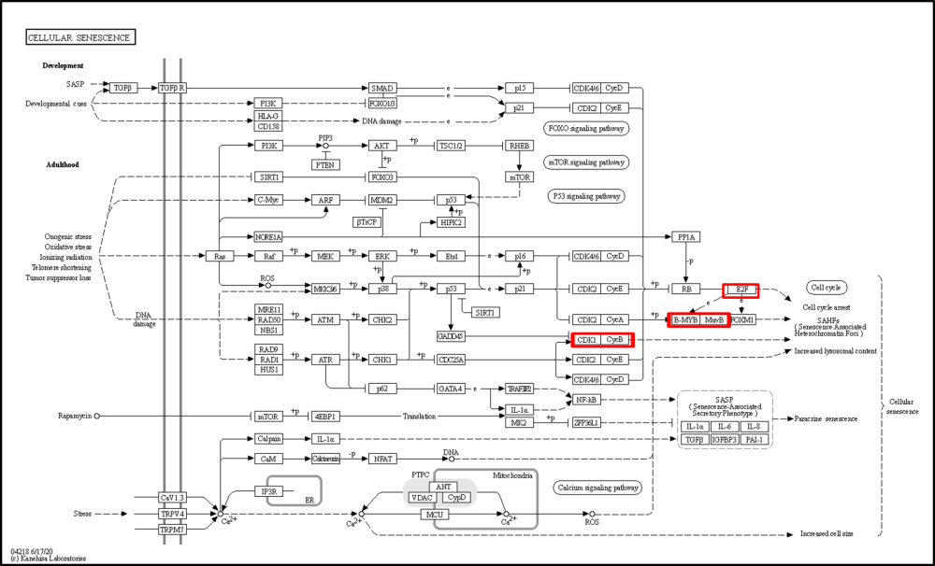
Cellular senescence pathway. Cellular senescence pathway mapped with significantly altered genes associated with altered expression of CAST.

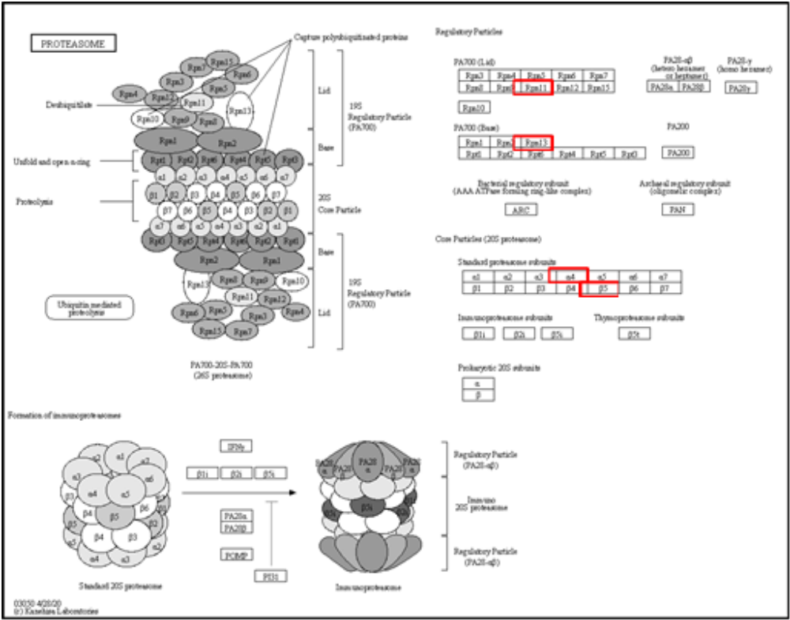
Proteasome pathway. Proteasome pathway mapped with significantly altered genes associated with altered expression of CAST.
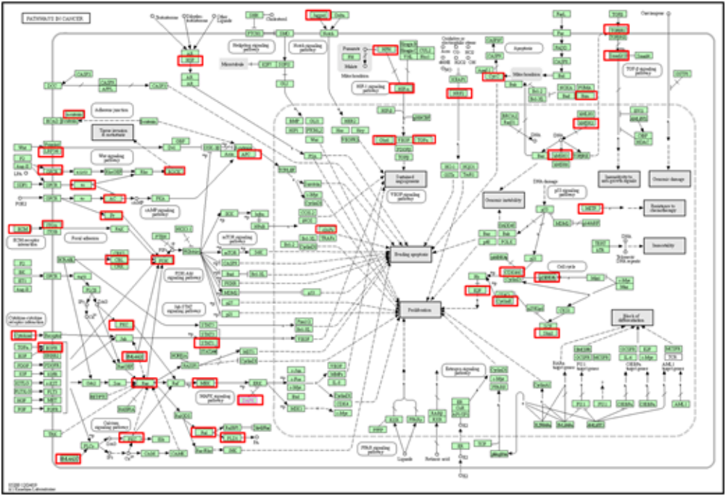
Pathways in cancer. Pathways in cancer mapped with significantly altered genes associated with altered expression of CAST.

